**A Project Report on**

**E-Intercarrier**

***In partial fulfillment for the award of the degree***

***Of***

**BACHELOR OF ENGINEERING**

**In**

**COMPUTER SCIENCE ENGINEERING**

**Submitted By**

**Patel Kinnari R. (120340131002)**

**Parekh Urvashi S. (120340131007)**

**Patel Jaimin J. (120340131054)**

**Guided By**

**Prof. Saumil Patel**

**Assistant Professor**



**Computer Science & Engineering Department**

**NARNARAYAN SHASTRI INSTITUTE OF TECHNOLOGY**

**Jetalpur**

**2015-2016**

**Acknowledgement**

We have taken efforts in this project. However, it would not have been possible without the kind support and help of many individuals . we would like to extend my sincere thanks to all of them.

We are highly indebted to Prof. Saumil Patel for his guidance and constant supervision as well as for providing necessary information regarding the project. We take this opportunity to thank all my friends and colleagues who started me out on the topic and provided extremely useful review feedback and for their all-time support and help in each and every aspect of the course of my project preparation. We are grateful to my college **Narnarayan Shashtri Institute of Technology, Jetalpur** ,for providing me all required resources and good working environment.

I would like to express my gratitude towards Head of Department, **Prof Piyush Patel**  and Director, **A. M. Patel sir** for their kind co-operation and encouragement which help me in this project.

**Patel Kinnari R. (120340131002)**

**Parekh Urvashi S.(120340131007)**

**Patel Jaimin J. (120340131054)**

**Abstract**

This app provides stock-tacking and inventory management in most simplistic way. Be it for your home or for the business. It will help you easily track your inventory. It also helps in managing purchase orders and sales orders. You can send those to suppliers or customer. Soon you can manage business expenses too.

So it is a complete app to run your business from mobile. This app develop of large scale of inventory stocks and Inward stock, utilize order and Reports (Sales, dead stock, return stock, replace stock).

|  |  |
| --- | --- |
| C:\Users\sanjay\Desktop\Backgrounds\NSIT Ahmedabad.JPG | **NARNARAYAN SHASHTRI INSTITUTE OF TECHNOLOGY**  **(Affiliated to Gujarat Technological University)**  Jetalpur, Tal: Dashkroi, Dist: Ahmedavad  Website: www.nsit.gurukul.in |

**CERTIFICATE**

This is to certify that the work of User Defined Project entitled **“E-Intercarrier*”*** has been carried out by ***Patel Kinnari R. (120340131002)*** under my guidance in partial fulfillment for the degree of Bachelor of Engineering in ***Computer Science & Engineering*** 7th Semester at the Computer Science & Engineering Department, ***Narnarayan Shashtri Institute of Technology***, Jetalpur, Ahmedabad, Gujarat, during the academic year 2015-2016 and her work is satisfactory. This student has successfully completed all the activity under my guidance related to Project for 7th semester.

|  |  |
| --- | --- |
| **Internal Guide,**  Saumil Patel  Assistant Professor,  Computer Science Engineering Department. | **Principal**  Dr. Sardadevi Mandalapu  NSIT,Jetalpur. |

**Prof. Piyush Patel,**

Head of Department,

Computer Science &Engineering,

Narnarayan Shashtri Institute of Technology

|  |  |
| --- | --- |
| C:\Users\sanjay\Desktop\Backgrounds\NSIT Ahmedabad.JPG | **NARNARAYAN SHASHTRI INSTITUTE OF TECHNOLOGY**  **(Affiliated to Gujarat Technological University)**  Jetalpur, Tal: Dashkroi, Dist: Ahmedavad  Website: www.nsit.gurukul.in |



**CERTIFICATE**

This is to certify that the work of User Defined Project entitled **“E-Intercarrier*”*** has been carried out by ***Parekh Urvashi S. (120340131007)*** under my guidance in partial fulfillment for the degree of Bachelor of Engineering in ***Computer Science & Engineering*** 7th Semester at the Computer Science & Engineering Department, ***Narnarayan Shashtri Institute of Technology***, Jetalpur, Ahmedabad, Gujarat, during the academic year 2015-2016 and her work is satisfactory. This student has successfully completed all the activity under my guidance related to Project for 7th semester.

|  |  |  |
| --- | --- | --- |
| **Internal Guide,**  Saumil Patel  Assistant Professor,  Computer Science Engineering Department. | **Principal**  Dr. Sardadevi Mandalapu  NSIT,Jetalpur. |  |

**Prof. Piyush Patel,**

Head of Department,

Computer Science &Engineering,

Narnarayan Shashtri Institute of Technology

|  |  |
| --- | --- |
| C:\Users\sanjay\Desktop\Backgrounds\NSIT Ahmedabad.JPG | **NARNARAYAN SHASHTRI INSTITUTE OF TECHNOLOGY**  **(Affiliated to Gujarat Technological University)**  Jetalpur, Tal: Dashkroi, Dist: Ahmedavad  Website: www.nsit.gurukul.in |

**CERTIFICATE**

This is to certify that the work of User Defined Project entitled **“E-Intercarrier*”*** has been carried out by ***Parekh Jaimin j. (1203401310054)*** under my guidance in partial fulfillment for the degree of Bachelor of Engineering in ***Computer Science & Engineering*** 7th Semester at the Computer Science & Engineering Department, ***Narnarayan Shashtri Institute of Technology***, Jetalpur, Ahmedabad, Gujarat, during the academic year 2015-2016 and her work is satisfactory. This student has successfully completed all the activity under my guidance related to Project for 7th semester.

|  |  |  |
| --- | --- | --- |
| **Internal Guide,**  Saumil Patel  Assistant Professor,  Computer Science Engineering Department. | **Principal**  Dr. Sardadevi Mandalapu  NSIT,Jetalpur. |  |

**Prof. Piyush Patel,**

Head of Department,

Computer Science &Engineering,

Narnarayan Shashtri Institute of Technology

**Content**

|  |  |
| --- | --- |
| Acknowledgement | I |
| Abstract | II |
| Certificate | III |
| Contents | IV |
| List of Figures | V |
| List of Tables | VI |
| Symbols And Abbreviations | VII |

|  |  |  |  |  |
| --- | --- | --- | --- | --- |
|  | | | | |
| **Chapter 1** | **Introduction** | | | 1 |
|  |  |  | | 2 |
|  | 1.1 | Project Detail | | 2 |
|  |  | 1.1.1 | Project Profile | 2 |
|  |  | 1.1.2 | Project Definition | 2 |
|  | 1.2 | Purpose | | 2 |
|  | 1.3 | Scope | | 2 |
|  | 1.4 | Objective | | 3 |
|  | 1.5 | Technology And Literature Review | | 3 |
|  | | | | |
| **Chapter 2** | **About The System** | | | 5 |
|  | 2.1 | System Requirement Specification | | 5 |
|  | 2.2 | Feasibility Study | | 10 |
|  | 2.3 | Project Planning | | 11 |
|  |  | 2.3.1 | Project Development Approach | 11 |
|  |  | 2.3.2 | Project Plan | 11 |
|  | | | | |
| **Chapter 3** | **Analysis** | | | 13 |
|  | 3.1 | Use Case Diagram | | 13 |
|  | 3.2 | DFD Diagram | | 14 |
|  | 3.3 | Sequence Diagram | | 22 |
|  | 3.4 | Activity Diagram | | 23 |
|  | 3.5 | ER Diagram | | 27 |
|  | 3.6 | Class Diagram | | 31 |
|  | | | | |
| **Chapter 4** | **Design** | | | 32 |
|  | 4.1 | System Flow Diagram | | 32 |
|  | 4.2 | Data Dictionary | | 32 |
|  |  |  | |  |
|  | | | | |
| **Chapter 5** | **Conclusion & Future Work** | | | 35 |
|  | 5.1 | Conclusion | | 35 |
|  | 5.2 | Future Work | | 35 |
| **Chapter 6** | **Implementation** | | | 37 |
|  | 6.1 | Implementation Environment | | 37 |
|  | 6.2  6.3  6.4 | Security  Coding Standards  Screen Shots | | 37 |
|  | | | | |
| **Appendix A** | **Document of Hands on exercise on Different Types of Canvas** | | |  |
| **Appendix B**  **Appendix C** | **PSAR Activity**  **PDE Form and Completion Certificate** | | |  |
|  | | | | |
|  | **References** | | |  |

**List of Figures**

|  |  |  |
| --- | --- | --- |
| **Figure Number** | **Description** | **Page Number** |
| Figure 1.1 | Introduction | 6 |
| Figure 4.1 | Use Case Diagram | 13 |
| Figure 4.2 | DFD | 14 |
| Figure 4.2.1 | Level-0 | 15 |
| Figure 4.2.2 | Level-1 | 16 |
| Figure 4.2.3 | Level-2 | 17 |
| Figure 4.2.3.1 | Registration | 17 |
| Figure 4.2.3.2 | Products | 18 |
| Figure 4.2.3.3 | Orders | 19 |
| Figure 4.2.3.4 | Inventory | 20 |
| Figure 4.2.3.5 | Reports | 21 |
| Figure 4.2.3.6 | Payment | 22 |
| Figure 4.3 | Sequence Diagram | 23 |
| Figure 4.3.1. | Store Employee | 24 |
| Figure 4.3.2 | Warehouse Manager | 25 |
| Figure 4.3.3 | Business Manager(Admin) | 25 |
| Figure 4.4 | Activity Diagram | 26 |
| Figure 4.4.1 | Store Employee | 27 |
| Figure 4.4.2 | Warehouse Manager | 28 |
| Figure 4.4.3 | Business Manager(Admin) | 29 |
| Figure 4.5 | ER Diagram | 29 |
| Figure 4.6 | Class Diagram | 30 |
|  |  |  |
|  |  |  |
|  |  |  |
|  |  |  |

**List of Table**

|  |  |  |
| --- | --- | --- |
| **Table Number** | **Description** | **Page Number** |
| Table 4.2.1 | Login | 34 |
| Table 4.2.2 | Store Employee Registration | 34 |
| Table 4.2.3 | Warehouse Details | 34 |
| Table 4.2.4 | Products | 35 |
| Table 4.2.5 | Order | 35 |
| Table 4.2.6 | Order Details | 35 |
| Table 4.2.7 | Store Product Stock | 35 |
| Table 4.2.8 | Warehouse Product Stock | 36 |
| Table 4.2.9  Table 4.2.10 | Minimum Quantity Stock  Coupon for store Store | 36 |

Table 4.2.11 Store To Store Transaction

Table 4.2.11 Store Payment

Table 4.2.12 Warehouse payment

**Symbols and Abbreviations**

|  |  |
| --- | --- |
| **Symbol** | **Description** |
| RAM | Random Access Memory |
| IDE | Integrated Development Environment |
| JSP | Java Server Page |
| JDK | Java Development Kit |
| J2EE | Java 2 Platform Enterprise Edition |
| J2ME | Java Platform Micro Edition |
| J2SE | Java 2 Platform Second Edition |

**CHAPTER-1 INTRODUCTION**

* 1. **Project Detail**

**1.2.1 Project Profile**

|  |  |
| --- | --- |
| Project Name: | E-Intercarrier |
|  |  |
| Project Duration | June 30, 2015 to March 30, 2016 |
| Team Size | 3 Members |
| Documentation | MS PowerPoint, MS Word, MS Visio, MS Excel |
| Front End | Html5, css3, java script, ajax, jsp, jquery |
| Back End | SQL Server 2008 |
|  |  |
| Internal Guide | Prof. Saumil Patel |

**1.2.2 Project definition**

* From basic essentials to a complete toolkit, our online E-Intercarrier takes care of whole event stock-tacking and inventory management in most simplistic way. it will help you easily track your inventory. This integrated system eliminates the need for multiple tools. Papers, registration and sessions are managed on a single system making every task simpler, faster and more accurate From managing entries, websites and judging to optional payments , Manage Order, inventory Management.
  1. **Purpose**
* The purpose is the ability to maintain a large size inventories for production and sales operation.
* It manages stock of the warehouse and store.
* It handles payment and billing of the different store.
* Some types of activities can be monitored by exception, reducing downtime.
* We are providing Inventory security for the better security.
* It handles better Payment Gateway Integration.
* We provide filtered data .
  1. **Scope**
* it provides complete app to run your business from mobile.
* We are providing inventory security for the better security.
* It includes better Payment Gateway Integration.
* We filtered data and also providing Stock history.
  1. **Objectives**

The main objectives of this system are as below:-

**Mapping System**

Through this function Store Employee and Warehouse Manager can create map according to their requirement. They can also get assets wise information. It provides more detailed information then current system.

**Authentication**

User is authenticated by entering user name and password. He/she must enter correct user name and password to use this application.

**Administrator**

In this functions Administrator are handle only database.

* 1. **Technology and literature review**

**Technology:**



**JAVA**

* Java is important and exciting advance in software technology. It enables you to build platform independent programs that executes on wide variety of hardware and software environments. Developers around the world are now using Java to build software for consumer devices; personal computers, minicomputers, and main frames .They are constructing mission-critical applications for many different industries.
* One of the important environments in which java is found is the internet.web pages can include references to small java programs known as applet that are dynamically retrieved from Web server and download to a user's machine Applets execute within the environment provided by web browser. They provide powerful ways for a user to interact with a webpage.
* The language includes several significant features. It is object-oriented and. therefore enables substantial code reuse. Exceptional handling is provided. This allows you to handle run time problems in an organized manner. Garbage collection is used to automatic reclaim the memory resources of objects that are no longer used. The java syntax is very straight forward. Some of the more troublesome features of the other language were deliberately omitted. Support for multithreaded program is available. These and other features make it much easier to write robust programming in Java.
* The java class library provides a wealth of functionality. Java is totally object-oriented programming.
* In Java, whatever we can do using the object.

**Java is Platform Independent**

* Java was designed to not only be cross-platform in source form like C, but also in compiled binary form. Since this is frankly impossible across processor architectures, Java is compiled to an intermediate form called byte-code.
* A Java program never really executes natively on the host machine. Rather a special native program called the Java interpreter reads the byte code and executes the corresponding native machine instructions. Thus to port Java programs to a new platform, all you need to do is run it with an interpreter written for the new platform. You don't even need to recompile. Even the compiler is written in Java. The byte codes are precisely defined, and remain the same on all platforms.
* The second important part of Java's cross-platform savvy is the elimination of undefined and architecture dependent constructs. Integers are always four bytes long, and floating point variables follow the IEEE 754 standard for computer arithmetic exactly. You don't have to worry that the meaning of an integer is going to change if you move from a Pentium to a PowerPC. In Java everything is guaranteed.
* However the virtual machine itself and some parts of the class library must be written in native code. These are not always as easy or as quick to port as pure Java programs. This is why for example, there's not yet a version of Java 1.2 for the Mac.

**Java is Safe**

* Java was designed from the ground up to allow for secure execution of code across a network, even when the source of that code was un-trusted and possibly malicious.
* This required the elimination of many features of C and C++. Most notably there are no pointers in Java. Java programs cannot access arbitrary addresses in memory. All memory access is handled behind the scenes by the (presumably) trusted runtime environment. Furthermore Java has strong typing. Variables must be declared, and variables do not change types when you aren't looking. Casts are strictly limited to casts between types that make sense. Thus you can cast an int to a long or a byte to a short but not a long to a Boolean or an int to a String.
* Java implements a robust exception handling mechanism to deal with both expected and unexpected errors. The worst that a Java program can do to a host system is bringing down the runtime environment. It cannot bring down the entire system.
* Most importantly Java applets can be executed in an environment that prohibits them from introducing viruses, deleting or modifying files, or otherwise destroying data and crashing the host computer. A Java enabled web browser checks the byte codes of an applet to verify that it doesn't do anything nasty before it will run the applet.
* However the biggest security problem is not hackers. It's not viruses. It's not Visual Basic worms transmitted by Outlook Express. It's not even insiders erasing their hard drives and quitting your company to go to work for your competitors. No, the biggest security issue in computing today is **bugs**. Regular, ordinary, non-malicious, unintended bugs are responsible for more data loss and lost productivity than all other factors combined. Java, by making it easier to write bug-free code, substantially improves the security of all kinds of programs.

**Java is High Performance**

* Java byte codes can be compiled on the fly to code that rivals C++ in speed using a "just-in-time compiler." Several companies are also working on native-machine-architecture compilers for Java. These will produce executable code that does not require a separate interpreter, and that is indistinguishable in speed from C++. While you'll never get that last ounce of speed out of a Java program that you might be able to wring from C or FORTRAN, the results will be suitable for all but the most demanding applications.
* As of May, 1999, the fastest VM, IBM's Java 1.1 VM for Windows, is very close to C++ on CPU-intensive operations that don't involve a lot of disk I/O or GUI work; C++ is itself only a few percent slower than C or FORTRAN on CPU intensive operations.
* It is certainly possible to write large programs in Java. The Hot Java web browser, the JBuilder integrated development environment and the java compiler are large programs that are written entirely in Java.

**Java is Multi-Threaded**

* Java is inherently multi-threaded. A single Java program can have many different processes executing independently and continuously. Three Java applets on the same page can run simultaneously with each getting equal time from the CPU with very little extra effort on the part of the programmer. This makes Java incredibly responsive to user input. It also helps to contribute to Java's robustness and provides a mechanism whereby the Java environment can ensure that a malicious applet doesn't steal all of the host's CPU cycles.
* Unfortunately multithreading is so tightly integrated with Java, that it makes Java rather difficult to port to architectures like Windows 3.1 or the PowerMac that don't natively support pre-emptive multi-threading.
* There is another cost associated with multi-threading. Multi-threading is to Java what pointer arithmetic is to C; that is, a source of devilishly hard to find bugs. Nonetheless, in simple programs it's possible to leave multi-threading alone and normally be OK.

**Java is dynamically linked**

* Java does not have an explicit link phase. Java source code is divided into .java files, roughly one per each class in your program. The compiler compiles these into .class files containing byte code. Each .java file generally produces exactly one .class file. (There are a few exceptions we'll discuss later, non-public classes and inner classes).
* The compiler searches the current directory and a few other well specified places to find other classes explicitly referenced by name in each source code file. If the file you're compiling depends on other, non-compiled files, then the compiler will try to find them and compile them as well. The Java compiler is quite smart, and can handle circular dependencies as well as methods that are used before they're declared. It also can determine whether a source code file has changed since the last time it was compiled.
* More importantly, classes that were unknown to a program when it was compiled can still be loaded into it at runtime. For example, a web browser can load applets of differing classes that it's never seen before without recompilation.
* Furthermore, Java .class files tend to be quite small, a few kilobytes at most. It is not necessary to link in large runtime libraries to produce an executable. Instead the necessary classes are loaded from the user's local system.

**Java is Garbage Collected**

* You do not need to explicitly allocate or deallocate memory in Java. Memory is allocated as needed, both on the stack and the heap, and reclaimed by the garbage collector when it is no longer needed. There are no malloc (), free (), or destructor methods. There are constructors and these do allocate memory on the heap, but this is transparent to the programmer.
* Most Java virtual machines use an inefficient, mark and sweep garbage collector. Some more recent virtual machines have improved matters quite a bit by using generational garbage collection.

**JSP (Java Server Pages)**



* A Java Server Page (JSP) is a template for a web page that uses Java code to generate an HTML document dynamically. JSPs are run in a server-side component known as a JSP container, which translates them into equivalent Java Servlets.
* For this reason, Servlets and JSP pages are intimately related. What’s possible in one is, in large part, also possible in another, although each technology has its individual strengths. Because they are Servlets, JSP pages have all the advantages of Servlets.

**Java Servlet**



* A Servlet is an object that receives a request and generates a response based on that request. The basic Servlet defines Java objects to represent Servlet requests and responses, as well as objects to reflect the servlet’s configuration parameters and execution environments.
* The package javax.servlet.http defines HTTP-specific subclasses of the generic Servlet elements, including session management objects that track multiple requests and responses between the web server and client.
* Servlets may be packaged in a WAR file as a web application.
* The Servlet API, contained in the Java package hierarchy javax.servlet.http, defines the expected interactions of a web container and a Servlet. A web container is essentially the component of a web server that interacts with the Servlets.
* The web container is responsible for managing the lifecycle of Servlets, mapping a URL to a particular Servlet and ensuring that the URL requester has the correct access rights.

**Framework**



* Apache Struts 2 is an elegant, extensible framework for creating enterprise-ready Java web applications. The framework is designed to streamline the full development cycle, from building, to deploying, to maintaining applications over time. Apache Struts 2 was originally known as Web Work 2.
* This tutorial will teach you how to use Apache Struts for creating enterprise-ready Java web applications in simple and easy steps.

**Struts 2 framework features:**

* Here are some of the great features that may force you to consider Struts2:
* **POJO forms and POJO actions** - Struts2 has done away with the Action Forms that were an integral part of the Struts framework. With Struts2, you can use any POJO to receive the form input. Similarly, you can now see any POJO as an Action class.
* **Tag support** - Struts2 has improved the form tags and the new tags allow the developers to write less code.
* **AJAX support** - Struts2 has recognised the takeover by Web2.0 technologies, and has integrated AJAX support into the product by creating AJAX tags, that function very similar to the standard Struts2 tags.
* **Easy Integration** - Integration with other frameworks like spring, Tiles and SiteMesh is now easier with a variety of integration available with Struts2.
* **Template Support** - Support for generating views using templates.
* **Plugin Support** - The core Struts2 behaviour can be enhanced and augmented by the use of plugins. A number of plugins are available for Struts2.
* **Profiling** - Struts2 offers integrated profiling to debug and profile the application. In addition to this, Struts also offers integrated debugging with the help of built in debugging tools.
* **Easy to modify tags** - Tag markups in Struts2 can be tweaked using Freemarker templates. This does not require JSP or java knowledge. Basic HTML, XML and CSS knowledge is enough to modify the tags.
* **Promote fewer configurations** - Struts2 promotes fewer configurations with the help of using default values for various settings. You don't have to configure something unless it deviates from the default settings set by Struts2.
* **View Technologies:** - Struts2 has a great support for multiple view options (JSP, Freemarker, Velocity and XSLT)

**Advantages of Struts2**

* **Simplified Design:** Code is not tightly coupled to Struts framework or Servlet API.
* **Easy plug-in:**Developers can use other technologies plug-in easily. It includes SiteMesh, spring, Tiles, etc.
* **Simplified Action Form:** ActionForms are POJOs, we do not need to implement any interface or extend from any class.
* **Annotations introduced:**Use of annotation results in reduction in length and complexity of code. It is also used in configuration file for simplicity.
* **Better tag features:**It includes theme based tags and Ajax enabled tags.
* **Simplified Testability:**Unit testing of Struts 2 Action class is very easy because it doesn’t need complex HttpServletRequest and HttpServletResponse objects.
* **Simplified Action:**Similar to ActionForms, Actions are also simple POJOs and they do not need to implement any interface or extend any class.
* **OGNL integration:**It uses OGNL to fetch data from ValueStack and type conversion which reduces code.
* **Ajax support:**Struts2 tags are Ajax enabled.
* **Multiple View options:**View is not restricted to JSP. Freemarker, velocity templates can also be used as a view.

**Advantages of JDBC**

* Relational persistence for JAVA
* Transparent persistence
* Database independent code
* Support for Query Language
* Optimize performance with caching
* Easily scalable

**My SQL**

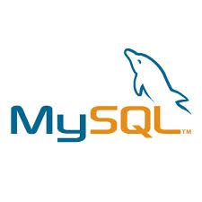

* MySQL is a popular choice of database for use in web applications, and is a central component of the widely used LAMP open source web application software stack (and other 'AMP' stacks).
* LAMP is an acronym for "Linux, Apache, MySql," Free-software-open source projects that require a full-featured database management system often use MySql.
* MySQL is a relational database management system (RDBMS), and ships with no GUI tools to administer MySQL databases or manage data contained within the databases. Users may use the included command line tools, or use MySQL "front-ends", desktop software and web applications that create and manage MySQL databases, build database structures, back up data, inspect status, and work with data records. The official set of MySQL front-end tools, MySQL Workbench is actively developed by Oracle, and is freely available for use.

**Apache Tomcat**



* **Apache Tomcat** (or simply **Tomcat**, formerly also *Jakarta Tomcat*) is an open source web server and servlet container developed by the Apache Software Foundation (ASF). Tomcat implements several Java EE specifications including Java Servlet, Java Server Pages (JSP), Java EL, and WebSocket, and provides a "pure Java" HTTP web server environment for Java code to run in.
* Apache is developed and maintained by an open community of developers under the auspices of the Apache Software Foundation, released under the Apache License 2.0 license, and is open-source software.

**Literature review:**

In existing sites they are not providing the all event in one web site which we are going to provide you in our site.

All existing system only manages the delivery from Warehouse to Stores.

Other System Providing Stock-Tracking and Inventory management in most simplistic way. Be it for your home or for the business.

**CHAPTER-2 ABOUT THE SYSTEM**

**2.1 System requirement specification**

**1 Introduction**

E_Intercarrier provides the tool to manage all such Stock entry online. Allows to order the stuff to the other stores if particular one store needed at a time .so all the Stores are internally connected with each other.

**E_Intercarrier** software of project management to the creation and development of large scale of inventory stock and Inward stock, utilize order and provides Reports(sales, dead stock, paid stock ,return stock, replaced stock).

## **1.2 Purpose**

## The purpose of Software Requirements Specification (SRS) document is to describe the external behavior of the online stock-tracking and inventory management in most simplistic way. Requirements Specification defines and describes the operations, interfaces, performance, and quality assurance requirements of the online payment gateway integration System. The document also describes the nonfunctional requirements such as the user interfaces. It also describes the design constraints that are to be considered when the system is to be designed, and other factors necessary to provide a complete and comprehensive description of the requirements for the software. The Software Requirements Specification (SRS) captures the complete software requirements for the system, or a portion of the system. Requirements described in this document are derived from the Vision Document prepared for the online stock-tracking and inventory management system.

.

## **1.3 Scope**

The Software Requirements Specification captures all the requirements in a single document. The E_Intercarrier that is to be developed provides the Store Employees, Warehouse manager and admin with stock delivering and online ordering the stuff between each stores . The E_Intercarrier supposed to have the following features.

**Proposed System**

* It is computerized system so no need of paper works.
* The system is very much user friendly.
* Communication between store employees internally and also with warehouse manager easy.
* Admin can easily maintain store’s information and also warehouse’s information.
* A employees can access our system from anywhere and anytime.

## **1.4 Definitions, Acronyms and Abbreviations**

* RAM: Random Access Memory
* IDE: Integrated Development Environment
* JSP: Java Server Page
* JDK: Java Development Kit

**1.5 References**

* http://www.asp.net/web-forms/tutorials
* www.realassetmgt.com
* www.usb.com
* www.myuniverse.com

## **Overview**

The SRS will provide a detailed description of the E_Intercarrier. This document will provide the outline of the requirements, overview of the characteristics and constraints of the system.

**E_Intercarrier** software of project management to the creation and development of large scale of inventory stock and Inward stock, utilize order and provides Reports(sales, dead stock, paid stock ,return stock, replaced stock).

## 2 **Overall description**

E_Intercarrier provides stock-tacking and inventory management in most simplistic way. Be it for your home or for the business.

It will help you easily track your inventory. It also helps in managing purchase orders and sales orders.

You can send those to suppliers or customer.

Soon you can manage business expenses too. so it is a complete app to run your business from mobile.

We are providing stock tracking security for the better security. It includes communication between the store employees.

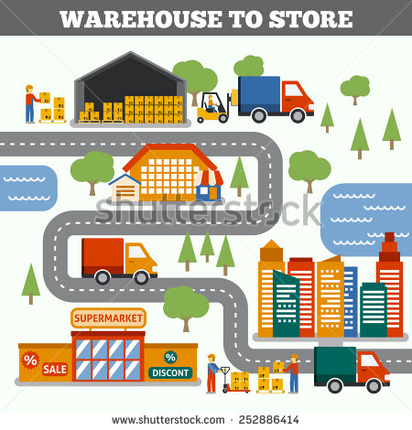

## **Specific Requirements**

This section describes in detail all the functional requirements.

## **Functionality**

**Expected Outcome**

* It is computerized system so no need of paper works.
* The system is very much user friendly.
* Communication between store employees internally and also with warehouse manager easy.
* Admin can easily maintain Store’s information and also Warehouse’s information.
* Employees can access system from anywhere and anytime.
* It is easy to access our system for all three users.
* A system maintains all the details of stocks and user’s info.
* It provides security in data privacy.

## **Usability**

The system shall allow the users to access the system from the Internet using HTML or its derivative technologies. The system uses a web browser as an interface. Since all users are familiar with the general usage of browsers, no specific training is required. The system is user friendly and self-explanatory.

## **Reliability**

The system has to be very reliable due to the importance of data and the damages incorrect or incomplete data can do.

### **3.3.1 Availability**

The system is available 100% for the users and is used 24 hrs. A day and 365 days a year. The system shall be operational 24 hours a day and 7 days a week.

### **Mean Time between Failures (MTBF)**

The system will be developed in such a way that it ***may*** fail once in a year.

### **Mean Time to Repair (MTTR)**

Even if the system fails, the system will be recovered back up within an hour or less.

### **Accuracy**

The accuracy of the system is limited by the accuracy of the speed at which the employees of the warehouse and users of the stores use the system.

### **Maximum Bugs or Defect Rate**

Not specified.

### **Access Reliability**

The system shall provide 100% access reliability.

## **Performance**

### **3.4.1 Response Time**

The Splash Page or Information page should be able to be downloaded within a minute using a 56K modem. The information is refreshed every two minutes. The access time for a device should be less than a minute. The system shall respond to the member in not less than two seconds from the time of the request submittal. The system shall be allowed to take more time when doing large processing jobs.

### **Administrator**

The system shall take as less time as possible to provide service to the administrator.

### **Throughput**

The number of transactions is directly dependent on the number of users; the users may be the Staff of Macdonald’s Warehouse, employees of the Macdonald’s franchises stores and also the business manager(admin) for checking seals, payment information and reports.

### **Capacity**

The system is capable of handling 250 users at a time.

### **Resource Utilization**

The resources are modified according the user requirements and also according to the products requested by the users.

## **Supportability**

The system designers shall take in to considerations the following supportability and technical limitations.

### **Internet Protocols**

The system shall be comply with the TCP/IP protocol standards and shall be designed accordingly.

### **Information Security Requirement**

The system shall support the UHCL information security requirements and use the same standard as the UHCL information security requirements.

### **Customer support System Data Compatibility**

The member balance amount that will be calculated and sent to the support system shall be compatible with the data types and design constraints of the support system.

### **Maintenance**

The maintenance of the system shall be done as per the maintenance contract.

### **Standards**

The coding standards and naming conventions will be as per the American standards

## **Design Constraints**

### **Software Language Use**

* Operating system: windows 2000/XP
* Web server: glassfish server
* Server side application software: net beans IDE7.0.1
* Languages : java script, HTML/CSS, JSP
* Database : MySQL
* Client browser: any web browser
* Java software: JDK 1.5.0

## **On-line User Documentation and Help System Requirements**

Online help is provided for each of the feature available with this system. All the applications provide an on-line help system to assist the user. The nature of these systems is unique to application development as they combine aspects of programming with aspects of technical writing (organization, presentation). Online help is provided for each and every feature provided by the system.

The User Manual describes the use of the system to admin, warehouse manager and store employee. The stores manual should be available as a hard copy and also as online help.

## **Purchased Components**

The System Administrator will need to purchase the license for IIS Server. Mostly it is available with Windows Environment. So the system need not purchase any licensing products.

## **Interfaces**

### **User Interfaces**

Will make use of the existing Web Browsers such as Microsoft Internet Explorer or Netscape. The user-interface of the system shall be designed as shown in the user-interface prototypes.

### **Hardware Interfaces**

The existing Local Area Network (LAN) will be used for collecting data from the users and also for updating the Library Catalogue.

### **Software Interfaces**

A firewall will be used with the server to prevent unauthorized access to the system.

### **Communications Interfaces**

The Dreamy creation will be connected to the World Wide Web.

## **Licensing Requirements**

No licensing requirements in Dreamy creation.

## **Legal, Copyright, and Other Notices**

## Our system does not provide any copyright.

## **Applicable Standards**

This style guide is intended to help the computer professional produce better Java programs. It presents a set of specific guidelines for using the features of Java in a disciplined manner. The goal is to develop high quality, reliable, reusable, portable software.

## **4. Supporting Information**

* Java
* Server management

**2.2 Feasibility study**

Feasibility is a practical extent to which a project can be performed successfully. To evaluate feasibility, a feasibility study is performed, which determines whether the solution considered to accomplish the requirements is practical and workable in the software or not. Such information as resource availability, cost estimate for software development, benefits of the software to organization, and cost to be incurred on its maintenance are considered. The objective of the feasibility study is to establish the reasons for developing software that is acceptable to users and adaptable to change.

There are various types of feasibility studies:

* Operational Feasibility
* Technical Feasibility
* Scheduling Feasibility
* Economic Feasibility
* Implementation Feasibility
  1. **Project Planning**
     1. **Project development approach**

Incremental model

* In incremental model the whole requirement is divided into various builds. Multiple development cycles take place here, making the life cycle a multi waterfall cycle.
* Cycles are divided up into smaller, more easily managed modules.  Each module passes through the requirements, design, implementation and testing phases.
* A working version of software is produced during the first module, so you have working software early on during the software life cycle.
* Each subsequent release of the module adds function to the previous release. The process continues till the complete system is achieved.

Why incremental model?

* Generates working software quickly and early during the software life cycle.
* This model is more flexible – less costly to change scope and requirements.
* It is easier to test and debug during a smaller iteration.
* In this model customer can respond to each built.
* Lowers initial delivery cost.
* Easier to manage risk because risky pieces are identified and handled during it’d iteration.

**2.3.2 Project plan**

Project Planning is an aspect of Project Management that focuses a lot on Project Integration. The project plan reflects the current status of all project activities and is used to monitor and control the project.

The Project Planning tasks ensure that various elements of the Project are coordinated and therefore guide the project execution.

Project Planning helps in

* Facilitating communication
* Monitoring/measuring the project progress, and
* Provides overall documentation of assumptions/planning decisions

The Project Planning Phases can be broadly classified as follows:

* Development of the Project Plan
* Execution of the Project Plan
* Change Control and Corrective Actions

The project milestone can be identified during the development of the project. This milestones and milestone deliverables are shown bellows as weekly progress. Scheduling of a software project does not differ greatly from scheduling of any multi task engineering effort.

month 1:

* Introduction to Institute.
* Introduction to Web Asset Management.

month 2:

* Studying various modules.
* Project planning.
* Started collecting the requirements.

month 3:

* Understanding the project in depth.
* Doing the requirement analysis.

month 4 :

* Requirement Classification & Feasibility Study.
* Time, Cost, Risk & Work Analysis.
* Model specification.

month 5:

* Creating Custom UML design based on analysis.
* Started System Flow Diagram.

month 6:

* Analysis and decided the flow of the project.
* Designed database.

month 7 :

* Designing
* Linked data with database such that add, update, and delete of the data can be done.

month 8:

* Coding
* Error and Exception Handling.

month 9:

* Coding and testing.
* Crystal Reports Generation.

month 10:

* Preparing the documentation of project.
* Given final demonstration of project.
* Final submission of project to the company.

## **CHAPTER-4 ANALYSIS**

* 1. **Use case model**



* 1. **DFD** 
     1. **0-level**



* + 1. **Level-1**



**4.2.3 level-2**

**4.2.3.1 Login**



**4.2.3.2 Products**



**4.2.3.3 Orders**



**4.2.3.4 Inventory**



**4.2.3.5 Payment**



**4.2.3.6 Reports**



**4.3 Sequence Diagram**

**4.3.1 For Store Employee**



* + 1. **For Warehouse Manager**



* + 1. **For Business Manager(admin)**



**4.4. Activity Diagram**

**4.4.1 For Store Employee**



4.4.2 For Warehouse manager



**4.4.3 For Business Manager(admin)**



**4.5 ER-Diagram**



**4.6 Class Diagram**

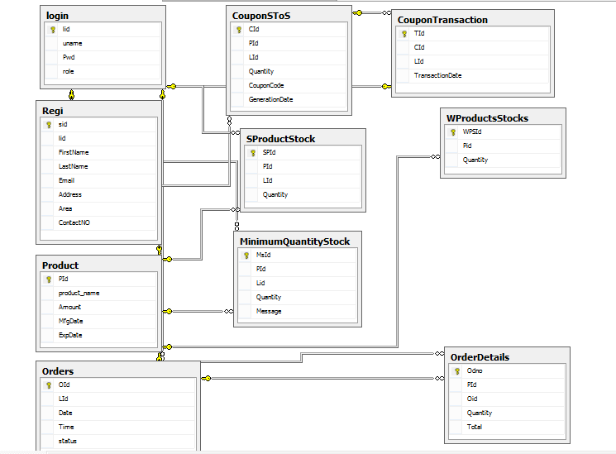

**CHAPTER-4 DESIGN**

* 1. **Data Dictionary** 
     1. **Login:**

|  |  |  |  |
| --- | --- | --- | --- |
| Field | Data type | Constraints | Description |
| Lid | Int | Primary key | Primary Key of login |
| Uname | Varchar(100) | Not null | **User name of user for login** |
| Password | Varchar(30) | Not null | Password for login |
| Roll | Varchar(20) | Not null | Identify user |

* + 1. **StoreRegistration:**

|  |  |  |  |
| --- | --- | --- | --- |
| Field | Data type | Constraints | Description |
| StoreId | Int | Primary key | Primary Key of store registration key |
| Lid | Int | Foreign key | **Primary key (Login)** |
| Name | Varchar(50) | Not null | Store name |
| Email | Varchar(100) | Not null | Email id of user |
| ContNo | Varchar(15) | Not null | Contact number of user |
| Address | Varchar(20) | Not null | Address of store |
| Area | Varchar(20) | Not null | Area of store |
| City | Varchar(20) | Not null | City of store |
| State | Varchar(20) | Not null | State of store |

**4.1.3 WarehouseDetails:**

|  |  |  |  |
| --- | --- | --- | --- |
| Field | Data type | Constraints | Description |
| WhouseId | Integer | Primary key | Primary Key of warehouse registration key |
| Lid | Integer | Foreign key | **Primary key (Login)** |
| Name | Varchar(20) | Not null | Warehouse name |
| Email | Varchar(20) | Not null | Email id of user |
| ContNo | Integer | Not null | Contact number of user |
| Address | Varchar(20) | Not null | Address of warehouse |
| Area | Varchar(20) | Not null | Area of warehouse |
| City | Varchar(20) | Not null | City of warehouse |
| State | Varchar(20) | Not null | State of warehouse |

* + 1. **Products**

|  |  |  |  |
| --- | --- | --- | --- |
| Field | Data type | Constraints | Description |
| PId | Integer | Primary key | Primary Key of product key |
| Product Name | Varchar(20) | Not null | Name of product |
| Amount | Long int | Not null | Price of product |
| ExpDate | Varchar(20) | Not null | Expire date of product |

* + 1. **Order:**

|  |  |  |  |
| --- | --- | --- | --- |
| Field | Datatype | Constraint | Description |
| Oid | Integer | Primary Key | Primary key of order |
| Lid | Integer | Foreign key | **Primary key (Login)** |
| OrderNo | Integer | Not null | Maintain the more than one order |
| Quantity | Integer | Not null | Quantity of product |
| Date of order | Date | Not null | Current date of order |

* + 1. **OrderDetails :**

|  |  |  |  |
| --- | --- | --- | --- |
| Field | Datatype | Constraint | Description |
| OdId | Integer | Primary key | Primary key of Order detail |
| PId | Integer | Foreign key | Primary Key( Product) |
| OrderNo | Integer | Not null | Maintain the more than one order |
| Quantity | Integer | Not null | Quantity of Order |

* + 1. **MinimumQuantityStock:**

|  |  |  |  |
| --- | --- | --- | --- |
| Field | Datatype | Constraint | Description |
| MsId | Integer | Primary key | Primary key of minimum stock quantity |
| PId | Integer | Foreign key | Primary Key( Product) |
| Lid | Integer | Foreign key | **Primary key (Login)** |
| Quantity | Integer | Not null | Quantity of Order |
| Message | Varchar(20) | null | Alert for stock |

* + 1. **StoreProductStock:**

|  |  |  |  |
| --- | --- | --- | --- |
| Field | Datatype | Constraint | Description |
| SpsId | Integer | Primary key | Primary key of store product stock |
| PId | Integer | Foreign key | Primary Key( Product) |
| Lid | Integer | Foreign key | **Primary key (Login)** |
| Quantity | Integer | Not null | Quantity of Order |

**4.1.8 WarehouseProductStock:**

|  |  |  |  |
| --- | --- | --- | --- |
| Field | Datatype | Constraint | Description |
| WpsId | Integer | Primary key | Primary key of warehouse product stock |
| PId | Integer | Foreign key | Primary Key( Product) |
| Lid | Integer | Foreign key | **Primary key (Login)** |
| Quantity | Integer | Not null | Quantity of Order |

* + 1. **CouponForStoreToStore:**

|  |  |  |  |
| --- | --- | --- | --- |
| Field | Datatype | Constraint | Description |
| Cid | Integer | Primary key | Primary key of coupon |
| PId | Integer | Foreign key | Primary Key( Product) |
| Lid | Integer | Foreign key | **Primary key (Login)** |
| Quantity | Integer | Not null | Quantity of Order |
| CouponCode | var | Not null | Generated automatic code through system |
| GenerateDate | Date/vr | Not null | Validity of coupon code |

* + 1. **StoreToStoreTransaction:**

|  |  |  |  |
| --- | --- | --- | --- |
| Field | Datatype | Constraint | Description |
| StstId | Integer | Primary key | Primary key of this table |
| Cid | Integer | Foreign key | Primary key (**CouponForStoreToStore)** |
| Lid | Integer | Foreign key | **Primary key (Login)** |
| Date Transaction | Integer | Not null | Supply order date |

* + 1. **Warehouse Sales:**

|  |  |  |  |
| --- | --- | --- | --- |
| Field | Datatype | Constraint | Description |
| WS_id | Integer | Primary key | Primary key of warehouse sales |
| O_id | Integer | Foreign key | Primary key(Order table) |

**4.1.11 Store Payment:**

|  |  |  |  |
| --- | --- | --- | --- |
| Field | Datatype | Constraint | Description |
| STP_id | Integer | Primary key | Primary key of store payment table |
| O_id | Integer | Foreign key | Primary key(order table) |
| Amount | Varchar(50) | Allow null | Comment |

**4.1.12 Warehouse Payment:**

|  |  |  |  |
| --- | --- | --- | --- |
| Field | Datatype | Constraint | Description |
| WAP_id | Integer | Primary key | Primary key of store payment table |
| WS_id | Integer | Foreign key | Primary key(warehouse sales table) |

**CHAPTER 5: CONCLUSION & FUTURE WORK**

**5.1 Conclusion**

Thus, the current system is proposing full automation to the previous system. All the plans and their tasks are distributed and integrated efficiently through the system. The proposed system estimates the more accurate cost for mining and profit the user can gain. It also gives the type and quantity of the expected minerals without mining the whole land. It just does some sample drilling so the cost for mining also decreases.

**5.2 Future Work**

In future the following features can be added to the system:

* Online location finding of products.
* Tracking of Vehicle Location.
* Mobile notifications

**Appendix A**

1. **Ideation Canvas**

**User Activities**

At this stage we will expand our list of user’s activities to list all possible new situations, conditions that users faces or may face. Focus on expanding activity list at this stage using ideation canvas at this stage. Ideation canvas is attached in append.

**Example:**

1. Make centralize database management system
2. Communication between warehouse and store
3. Warehouse manager add/delete/update products
4. Store employee add/delete/update products and orders
5. Admin handle financial decision and payment

**Problem Identification**

At this stage we will identify the problems user may face by analyzing and studying all the variations of his activities. Travelling out is not a problem unless it is raining. Often normal activities done under situations lead to problems. We will identify such problems at this stage.

**Example:**

1. So many data to be required to manage all Product and order details and also there data should be identical.
2. Unique Identification required when while store to store connectivity

**Solution Identification**

Now that Problems have been identified,it’s time to start looking at the slutions.Using the ideation canvas we will look at how we can ideate about solution to the problems.

**Example:**

1. Make centralise system to manage whole data
2. Also product will unique according to their details

**People**

In this stage we will identify the users who are use this application

**Example:**

1. Warehouse manager
2. Admin
3. Store Employee

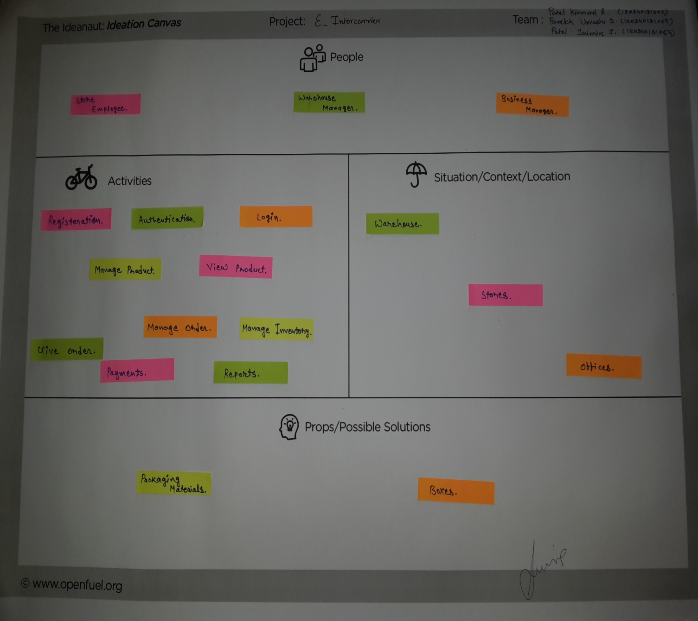

**Fig (I) Ideation Canvas**

**(2) Production Development Canvas**

**People**

Now we will start with the product development canvas. Product canvas will require us to start building a structure of our product around the emotional needs of the users. Building solutions around the emotive needs of users is central to design thinking.

**Example:**

1. Admin
2. Warehouse manager
3. Store Employee

**Purpose**

By now you are very clear about the people whose problem you are solving. To begin with the new Product development canvas, just rewrite down the people & the problem statement under the purpose.

**Example:**

* Manage Order
* Mange Employee
* Manage warehouse manager
* Utilize order
* Inward stock
* View product details
* Billing and payment
* Reports(sales, dead stock, paid stock,

return stock, replaced stock)

**Product Experience**

It is time to draw interferences from the empathy stage of our process. Since we know now what we should describe the user experience for the user when he will use your solution. At this stage you need to put down the emotional experience you want the user to have when he will use your solution

**Example:**

1. Easy to find product details
2. Time saving
3. Compatable

**Product Functions**

* If you’ve already everything your product does then it’s time to organize that list. Or if you have not, then prepare one list of everything your solution does.
* Once you’ve completed the list, we will start arranging the list into points that do similar things, E.g. If you’ve made a car that has better seatbelts and better cushioning by airbags during accident-then both these things do the same thing-increase user safety.

**Example:**

1. Notification when order successfully placed
2. Sending mail after Registration of store

**Product Features**

* Everything that your solution does is a feature. Many features do the same thing. If your solution has two features- use your mobile touchpad to type search terms or use voice command to tell your phone what to search. In this case both the features do the same thing-allow user to search
* Group all your features into groups where they do the same thing. It is possible that one feature may be part of two groups.

**Example:**

* Manage Order
* Mange Employee
* Manage warehouse manager
* Utilize order
* Inward stock
* View product details
* Billing and payment
* Reports(sales, dead stock, paid stock,

return stock, replaced stock)

**Components**

At this stage we will complete the product development tree. To do this we further make a list of all the components that will be required to make each feature that we have listed. We can also list sub parts or sub components for each features

**Example:**

1. Paypal
2. SMTP
3. JASPER Report Generation tool

**Customer revalidation**

* Post prototype creation, you can take it to the user and ask for his feedback.
* Ask if this will solve his problems or will this lead to a good user experience. Some solution can solve the problem and yet no make the user feel comfortable or good.
* Check if the user experience you defined earlier is being fulfilled besides the problem being solved. Fill the user feedback in the validation block of your product development canvas.
* **Example:**

1. Store’s unique identification is required

**Reject/Redesign/Retain**

* Some features of functions can solve customer problem but don’t provide great user experience. Second fill your need for transportation but don’t provide the prestige that comes with owning a firsthand car.
* Redesign those features that can be redesigned to better suit the user needs. Reject those features & functions that fail completely and can’t be redesigned to meet user needs.
* If a function is rejected, all related features are also rejected automatically. So check for function level validation first.
* Those function-features that fill all user needs-great customer experience & solve the problem can be retained as such

**Example:**

1. We provide unique Id to all Stores

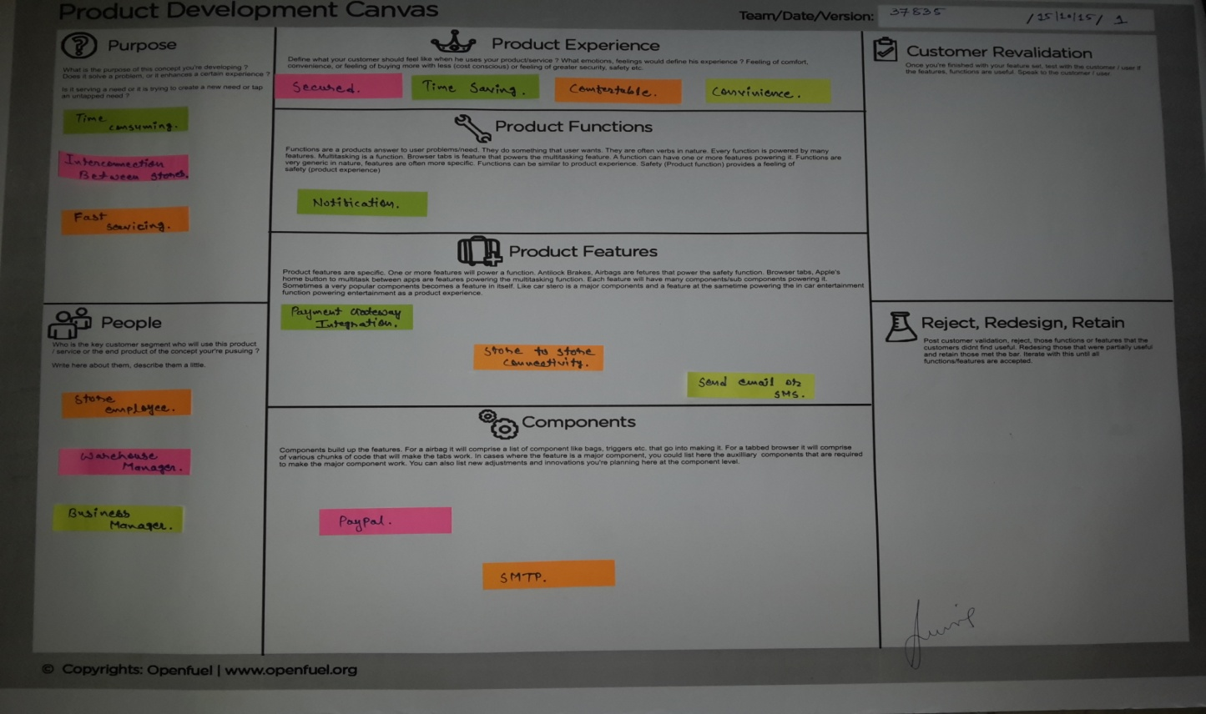

**Fig. (II)** **Product Development Canvas**

**(3)Business Model Canvas**

**Objectives of BMC**

* The Business Model Canvas is used to validate the market significance of products and services, taken up for the project in this case. Technology projects are often solutions or processes that solve a technical problem.
* However the implementation for the market of such solutions also requires that the problem solution is designed not only to overcome not just the technical barriers but also to market-and-business related barriers of costs, customer-reach and collaborations.
* Thus a business model canvas can be used to visualize market problems and customer expectations. This exercise will increase the market potential and penetration of technology goods and services. This will make them more effective in market.
* This exercise will bring discussions on viability and cost effectiveness into picture along with their clear impact.
* This exercise will enable students to have a clear understanding on the steps required to ensure that whatever solution they develop as their project should have a user who can afford it with desired needs.
* This exercise also helps students to understand the true value of the proposed solution.

**Key Partners:-**

* Delhi Police Station Website
* Police Station Management System
* Crime Report Management System
* For help to improve our system implementation, we need some reference site for example online crime reporting system.

**Key Activities:-**

* Case wise Report generation
* Production
* Selling
* What kind of activities required in this system like report generation and Production and Selling also.

**Value Propositions:-**

* Reduce Workload
* Time efficient
* Add, Update and Delete Case Records, Criminal Records
* Data Security
* What Value Provide to users of this system is including in Value Propositions. So workload will be reduce and also time efficient, because manually entry will not done.

**Customer Relationship:-**

* Personal Assistance
* Self service
* Communities
* Police Station Staff Member also has to communicate us if they will find any problems in future. They have to make communities for this.

**Customer Segments:-**

* Police Station Staff Members
* This Web Application Basically design for Police Station Staff Members. So this system mainly used for Police Department.

**Key Resources:-**

* Laptop for Coding
* Human Resources
* Internet Providers
* Some additional Resources required for Implementation of this system, So we require Computer system basically and also human resources. Also need Internet Connection to learn and solve some problems.

**Channels:-**

* Internet is required for running our system
* This is web application made for Police Station Staff so we have to communicate to them directly
* Mainly design for police station staff so need not to sell this application on website so we have to directly meet them and explain them.

**Cost Structure:-**

* Physical cost is high
* Computers and Laptops are expensive
* Internet Connection
* Production Cost
* These include what kind of cost structure will use in our system, like computers and Internet Connection.

**Revenue Streams:-**

* Fast and Efficient Sharing of Records
* Less Workload
* Uniqueness
* Some features of our system are listed above; like that this system will provide uniqueness.

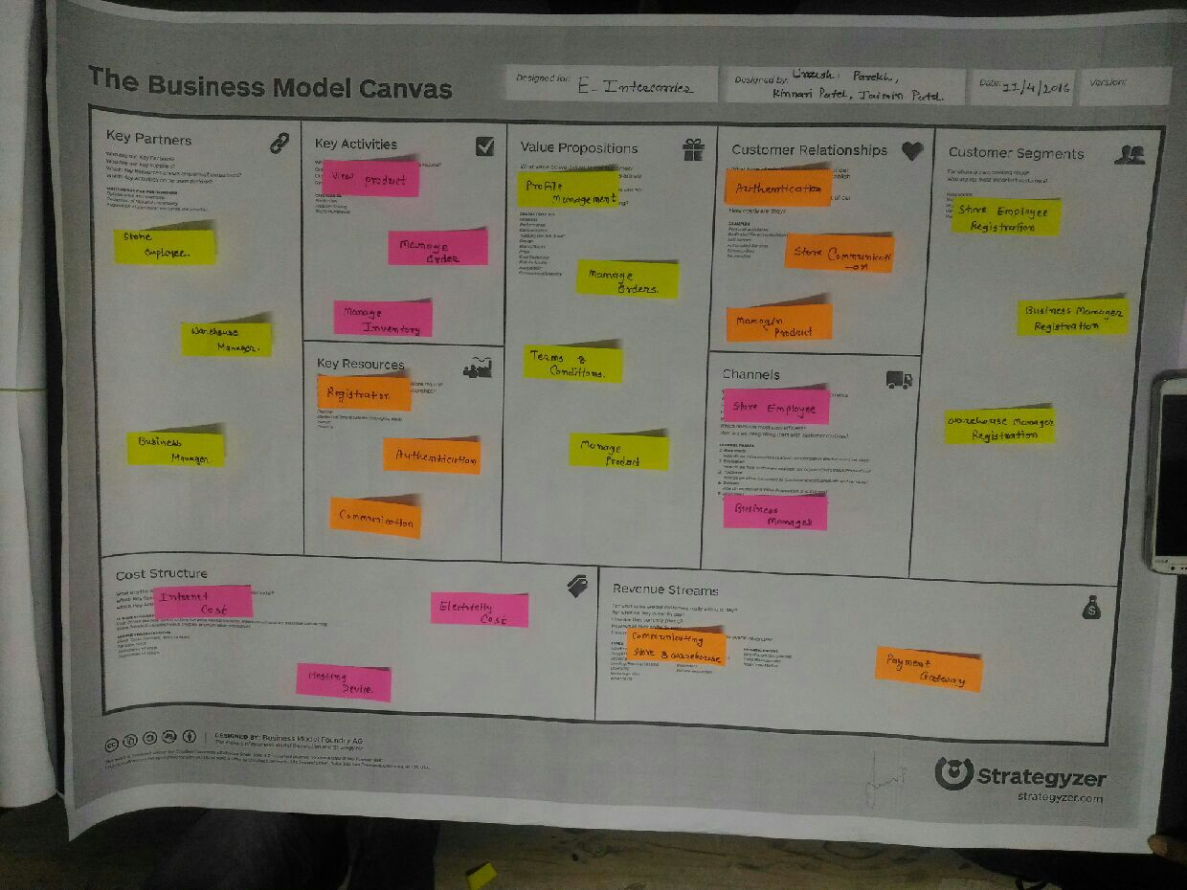

**Fig. (II)** **Business Model Canvas**

**CHAPTER-6 IMPLEMENTATION**

This phase decided that how will we actually implement planning with the coding as before implementing planning it’s important to plan it initially. The analysis and design of the system gives us the base for the further development and making pave for the implementation, technology, language, framework, database, etc. to be selected so as to build an efficient system.

**6.1 Implementation Environment**

|  |  |
| --- | --- |
| Timeline/Date Range | Project Stage/Milestone |
| October-2015 | - Implementation Planning  - Planning design |
| November-2015 | -Theme Design |
| November-2015 | -Installing Theme in Eclipse  -Connection of Java application to MY SQL  -Creation of Registration Forms  -Make database connectivity to pages |
| January-2016 | -Implement different functionalities |
| April-2016 | -User Management |

**Table: Implementation Planning**

**6.2 Security**

* Any infrastructure/application development for the web should adhere to the Security Policy detailed by the organization. It is assumed that the system has a detailed Security options for protecting its information.
* What follows is a “common” approach for protecting the resources and information when a web application is published in the web or in any Local Area Network where multiple users are going to access or append the data.

**Security Layers:** Minimize security risks by deploying multiple layers of security controls:

* Application Security
* Database Security

**6.2.1 Application security**

Single sign-on provides users with a single point of entry to all authorized applications with a single authentication or login process. Application Server Security includes

* **Identification:** System supports user identification, which is a secure repository for Identification & authorization information. Each user of the system will be given a unique username / security code number.
* **Authentication:** System supports strong user Authentication. Server Password-based authentication will support Password-based schemes, to be secure, must facilitate change of passwords regularly, sufficient complexity and cannot be easily guessed.
* **Authorization:** User Authorization in the system is implemented as access control. Access control deals with the concept of who has access to what information and what type of operations can be accessed. System provides a strong set of access control security mechanisms through privileges. Application enforces the Principle of Least Privilege - that is, granting only those privileges to a user that allows him to perform his job functions, but no more. This ensures that the users will only be able to access files and data that they are privileged to.

The access control Module in system is defined for creation, opening and editing of objects/data and by route – users not in the route of a file will not be able to access the file.

**Data Confidentiality:** Encryption is the mechanism that is used to provide data confidentiality. It is used to store passwords in encrypted form so that no user can see it, not even the administrator of the system.

**6.2.2 Database security**

**Server-Enforced, Row Level Access Control:** The system will be the using RDBMS Databases. These databases will be deployed on the server and database access checks will be defined at the system level. No direct access is granted to RDBMS Databases, all access to these databases is via applications and hence governed by Access controls.

**6.3 Coding Standards**

* To maintain a uniform standard in coding patterns I have used same coding styles throughout the project. The main objective of having a standard in coding is that, while yet coding, it is much easier to make changes in the code when it is necessary to do so. The changes to make and where to make them are far less cumbersome and more efficient and time saving if the scripts written follow same style.
* Not only it helps while writing the code for the first time but after I have completed the project it is much easier to test for bugs in the script and I could easily find a piece of code out of so many files and thousands of lines of coding. Either of us can check and correct the mistakes without the code to get all mixed up in different style of writing solution.
* Even after a long period of time, if we would like to extend our project and start from where I left last time it would not be hard as we already know how the code is written.

In all, a uniform pattern while coding or writing scripts helps maintain the project better during the development as well as in future extensions. We have followed the following standards in our code:

* **Comments:** For the sake of future reference as well as for better understanding of the code I have written comment blocks throughout the project. Comments help us remember what the piece of code does for which the comment was written.
* **Capitalization:** While writing various queries for insert, update or select etc., I have written the query keywords in capital letters so as to distinguish them from the table names or other words.
* **Curly Braces:** When the use of curly braces occur in writing JavaScript functions or PHP functions or looping structures, conditional structures etc., I have started the brace right after the function or looping or conditional structures end, instead of starting it from the next line.
* **CSS files:** I have used css file in our project that define various styles of different types of headings and other texts that appear in user interface. Including css file helped me reduce many lines of repetitive coding that I might have had done if I wanted the user interface to look same in all the modules.

**6.3 Screen Shots**

**Appendix B**

1. **PPR**

**Submitted By: Parekh Urvashi S.**

|  |
| --- |
| **Periodic Progress Report :First PPR** |
| |  |  | | --- | --- | | **Project** | : E-Intercarrier | |
| **Status :** Submitted  (Freeze) |
| 1. **What Progress you have made in the Project?**   We design Registration,login and Homepage for users. |
| 1. **What challenge you have faced?** |
| Template integration according to my project, and authentication functionality in login . |
| 1. **What support you need?** |
| To solve above problem, we contact our guide. He helped us to solve problem and he improve our designing of project. Google,DBMS book,SQL query book |
| 1. **Which literature you have referred?**   Basically there is no book available for struts2 so we refer some websites like tutorialspoint,stackoverflow,thinktibits,javapoint etc. Web Designing tools on W3 Schools :https://w3layouts.com/ W3Schools :http://www.w3schools.com/ |
|  |

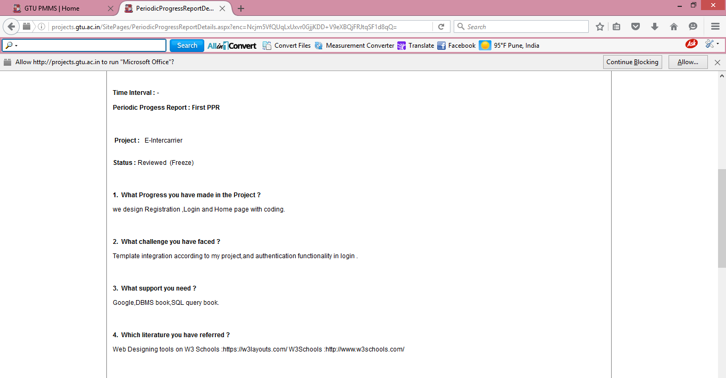

|  |
| --- |
| **Periodic Progress Report : Second PPR** |
| |  |  | | --- | --- | | **Project:** | E-Intercarrier | |
| **Status :** Submitted  (Freeze) |
| **1. What Progress you have made in the Project?** |
| we design landing page, Products Add, update and delete page, Orders view page as well. |
| **2. What challenge you have faced?** |
| |  | | --- | | menu-bar template integration in our template,Hibernate connectivity with Database. | |  | |  | |
| **3. What support you need?** |
| |  | | --- | | Google,DBMS book ,JAVA reference book. | |  | |  | |
| **4. Which literature you have referred?** |
| |  | | --- | | w3Schools:http://www.w3schools.com/ For download JAR file:http://www.oracle.com/technetwork/java/javasebusiness/downloads/java-archive-downloads-eeplat-419426.html Hibernate connectivity:http://www.tutorialspoint.com/hibernate/hibernate_configuration.htm | |  | |  | |
|  |

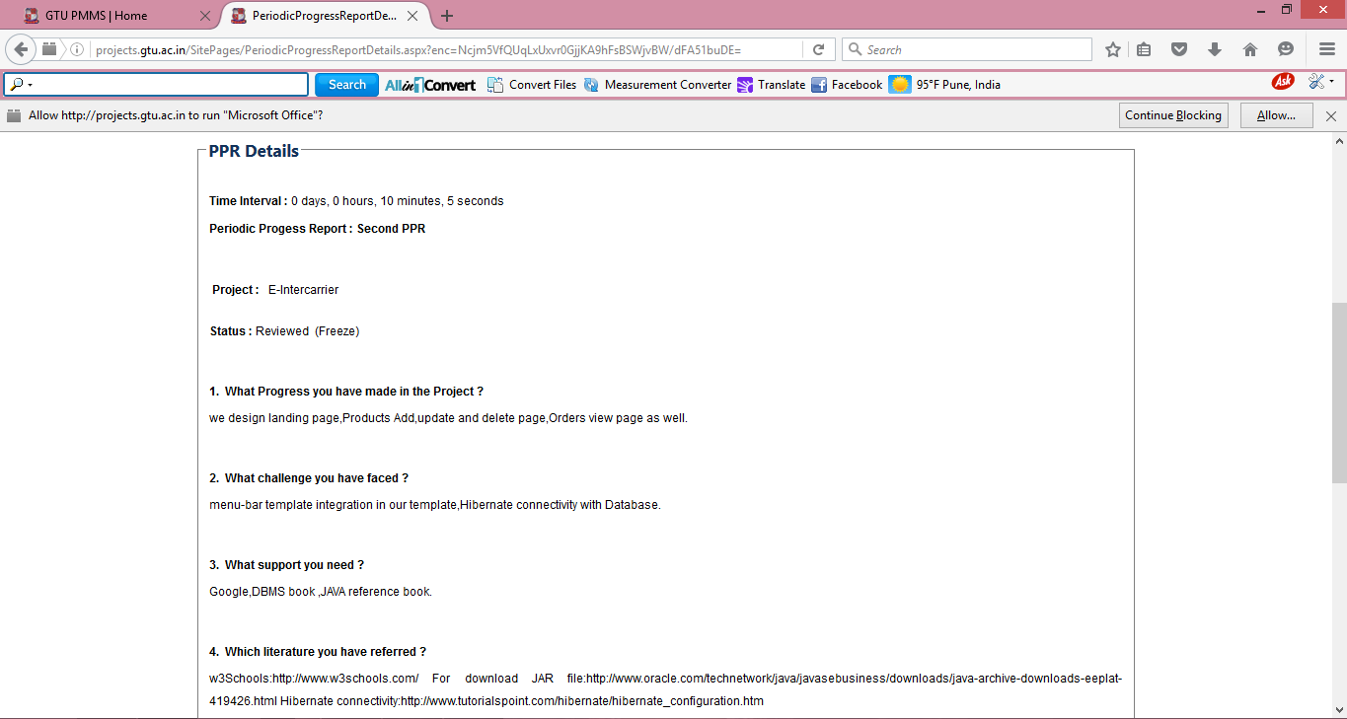

|  |
| --- |
| **Periodic Progress Report : Third PPR** |
| |  |  | | --- | --- | | **Project:** | E-Intercarrier | |
| **Status :** Submitted  (Freeze) |
| **1. What Progress you have made in the Project?** |
| |  | | --- | | Designing the webpages and coding of our main functionality of project, Payment is added using PAYPAL. | |  | |  | |
| **2. What challenge you have faced?** |
| |  | | --- | | Servlates problem ,Combining of two models details, Tabular CSS Instigation in templates css. | |  | |  | |
| **3. What support you need?** |
| Google,JAVA Reference Book for Coding. |
| **4. Which literature you have referred?** |
| |  | | --- | | http://info.dogpile.com/dogpl.305.02/search/web?q=w3schools+java+programming&ad.network=g&ad.keyword=w3schools%20java%20programming&ad.creative=88060886762&ad.position=1t1&ad.placement=&ad.matchtype=b&ad.aceid=&ad.ismobile=&ad.device=c&ad.devicemodel=&ad.adgroupid=25905779402&cid=363130442&ad.segment=dogpl.305.02 | |  | |  | |
|  |

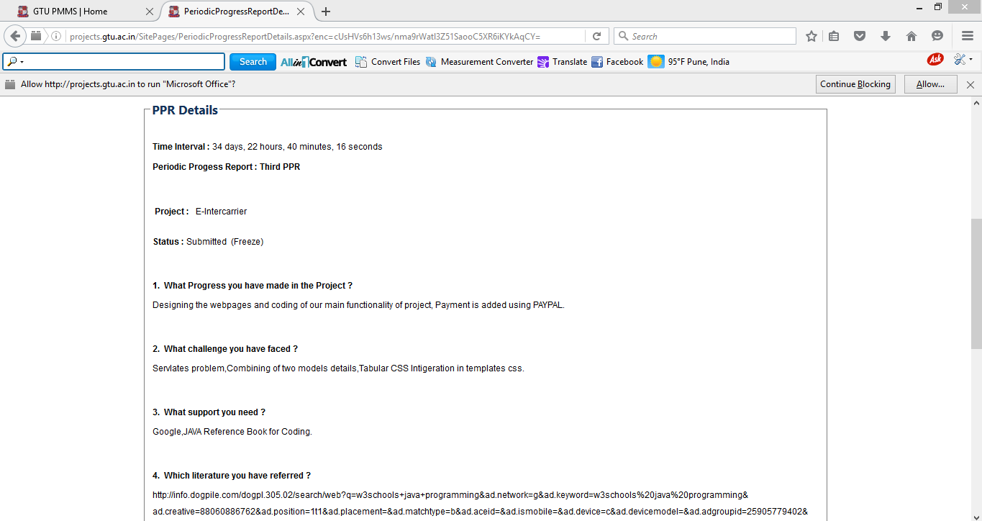

|  |
| --- |
| **Periodic Progress Report : Forth PPR** |
| |  |  | | --- | --- | | **Project** | E-Intercarrier | |
| **Status :** Submitted  (Freeze) |
| **1. What Progress you have made in the Project?** |
| |  | | --- | | Report Generation using PAYPAL,Filtering Apply on Project,validation done | |  | |  | |
| **2. What challenge you have faced?** |
| During Filter page Ridirect the page plm,while testing some compilation error |
| **3. What support you need?** |
| Google. |
| **4. Which literature you have referred?** |
| https://reportserver.net/en/?gclid=CIqbv-br_MsCFQ8kaAodrBgMLQ |

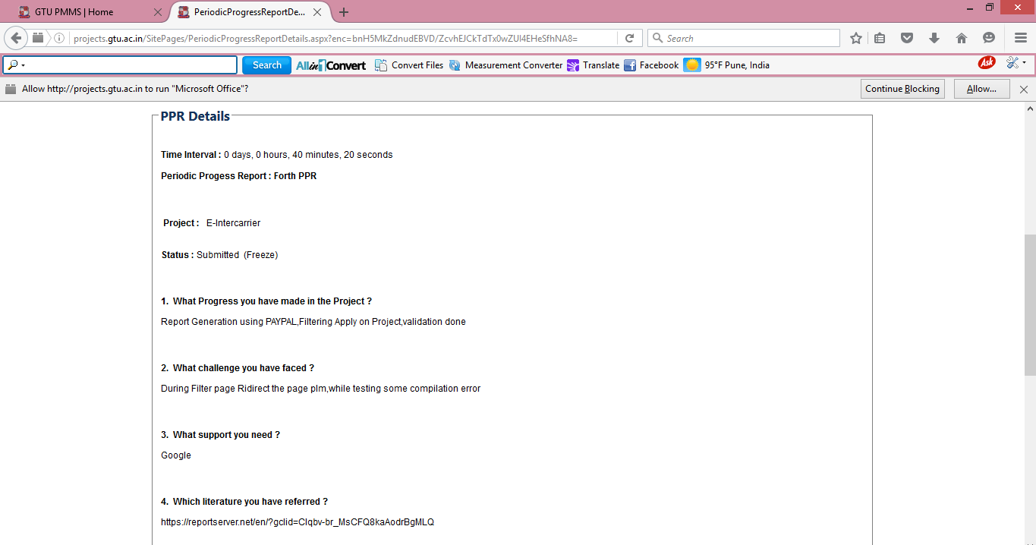

**Submitted By: Patel Kinnari R.**

|  |
| --- |
| **Periodic Progress Report :First PPR** |
| |  |  | | --- | --- | | **Project** | : E-Intercarrier | |
| **Status :** Submitted  (Freeze) |
| 1. **What Progress you have made in the Project?**   We design Registration,login and Homepage for users. |
| 1. **What challenge you have faced?** |
| Template integration according to my project, and authentication functionality in login . |
| 1. **What support you need?** |
| To solve above problem, we contact our guide. He helped us to solve problem and he improve our designing of project. Google,DBMS book,SQL query book |
| 1. **Which literature you have referred?**   Basically there is no book available for struts2 so we refer some websites like tutorialspoint,stackoverflow,thinktibits,javapoint etc. Web Designing tools on W3 Schools :https://w3layouts.com/ W3Schools :http://www.w3schools.com/ |
|  |



|  |
| --- |
| **Periodic Progress Report : Second PPR** |
| |  |  | | --- | --- | | **Project:** | E-Intercarrier | |
| **Status :** Submitted  (Freeze) |
| **1. What Progress you have made in the Project?** |
| we design landing page, Products Add, update and delete page, Orders view page as well. |
| **2. What challenge you have faced?** |
| |  | | --- | | menu-bar template integration in our template,Hibernate connectivity with Database. | |  | |  | |
| **3. What support you need?** |
| |  | | --- | | Google,DBMS book ,JAVA reference book. | |  | |  | |
| **4. Which literature you have referred?** |
| |  | | --- | | w3Schools:http://www.w3schools.com/ For download JAR file:http://www.oracle.com/technetwork/java/javasebusiness/downloads/java-archive-downloads-eeplat-419426.html Hibernate connectivity:http://www.tutorialspoint.com/hibernate/hibernate_configuration.htm | |  | |  | |
|  |



|  |
| --- |
| **Periodic Progress Report : Third PPR** |
| |  |  | | --- | --- | | **Project:** | E-Intercarrier | |
| **Status :** Submitted  (Freeze) |
| **1. What Progress you have made in the Project?** |
| |  | | --- | | Designing the webpages and coding of our main functionality of project, Payment is added using PAYPAL. | |  | |  | |
| **2. What challenge you have faced?** |
| |  | | --- | | Servlates problem ,Combining of two models details, Tabular CSS Instigation in templates css. | |  | |  | |
| **3. What support you need?** |
| Google,JAVA Reference Book for Coding. |
| **4. Which literature you have referred?** |
| |  | | --- | | http://info.dogpile.com/dogpl.305.02/search/web?q=w3schools+java+programming&ad.network=g&ad.keyword=w3schools%20java%20programming&ad.creative=88060886762&ad.position=1t1&ad.placement=&ad.matchtype=b&ad.aceid=&ad.ismobile=&ad.device=c&ad.devicemodel=&ad.adgroupid=25905779402&cid=363130442&ad.segment=dogpl.305.02 | |  | |  | |
|  |



|  |
| --- |
| **Periodic Progress Report : Forth PPR** |
| |  |  | | --- | --- | | **Project** | E-Intercarrier | |
| **Status :** Submitted  (Freeze) |
| **1. What Progress you have made in the Project?** |
| |  | | --- | | Report Generation using PAYPAL,Filtering Apply on Project,validation done | |  | |  | |
| **2. What challenge you have faced?** |
| During Filter page Ridirect the page plm,while testing some compilation error |
| **3. What support you need?** |
| Google. |
| **4. Which literature you have referred?** |
| https://reportserver.net/en/?gclid=CIqbv-br_MsCFQ8kaAodrBgMLQ |



**Submitted By: Patel Jaimin J.**

|  |
| --- |
| **Periodic Progress Report :First PPR** |
| |  |  | | --- | --- | | **Project** | : E-Intercarrier | |
| **Status :** Submitted  (Freeze) |
| 1. **What Progress you have made in the Project?**   We design Registration,login and Homepage for users. |
| 1. **What challenge you have faced?** |
| Template integration according to my project, and authentication functionality in login . |
| 1. **What support you need?** |
| To solve above problem, we contact our guide. He helped us to solve problem and he improve our designing of project. Google,DBMS book,SQL query book |
| 1. **Which literature you have referred?**   Basically there is no book available for struts2 so we refer some websites like tutorialspoint,stackoverflow,thinktibits,javapoint etc. Web Designing tools on W3 Schools :https://w3layouts.com/ W3Schools :http://www.w3schools.com/ |
|  |



|  |
| --- |
| **Periodic Progress Report : Second PPR** |
| |  |  | | --- | --- | | **Project:** | E-Intercarrier | |
| **Status :** Submitted  (Freeze) |
| **1. What Progress you have made in the Project?** |
| we design landing page, Products Add, update and delete page, Orders view page as well. |
| **2. What challenge you have faced?** |
| |  | | --- | | menu-bar template integration in our template,Hibernate connectivity with Database. | |  | |  | |
| **3. What support you need?** |
| |  | | --- | | Google,DBMS book ,JAVA reference book. | |  | |  | |
| **4. Which literature you have referred?** |
| |  | | --- | | w3Schools:http://www.w3schools.com/ For download JAR file:http://www.oracle.com/technetwork/java/javasebusiness/downloads/java-archive-downloads-eeplat-419426.html Hibernate connectivity:http://www.tutorialspoint.com/hibernate/hibernate_configuration.htm | |  | |  | |
|  |



|  |
| --- |
| **Periodic Progress Report : Third PPR** |
| |  |  | | --- | --- | | **Project:** | E-Intercarrier | |
| **Status :** Submitted  (Freeze) |
| **1. What Progress you have made in the Project?** |
| |  | | --- | | Designing the webpages and coding of our main functionality of project, Payment is added using PAYPAL. | |  | |  | |
| **2. What challenge you have faced?** |
| |  | | --- | | Servlates problem ,Combining of two models details, Tabular CSS Instigation in templates css. | |  | |  | |
| **3. What support you need?** |
| Google,JAVA Reference Book for Coding. |
| **4. Which literature you have referred?** |
| |  | | --- | | http://info.dogpile.com/dogpl.305.02/search/web?q=w3schools+java+programming&ad.network=g&ad.keyword=w3schools%20java%20programming&ad.creative=88060886762&ad.position=1t1&ad.placement=&ad.matchtype=b&ad.aceid=&ad.ismobile=&ad.device=c&ad.devicemodel=&ad.adgroupid=25905779402&cid=363130442&ad.segment=dogpl.305.02 | |  | |  | |
|  |



|  |
| --- |
| **Periodic Progress Report : Forth PPR** |
| |  |  | | --- | --- | | **Project** | E-Intercarrier | |
| **Status :** Submitted  (Freeze) |
| **1. What Progress you have made in the Project?** |
| |  | | --- | | Report Generation using PAYPAL,Filtering Apply on Project,validation done | |  | |  | |
| **2. What challenge you have faced?** |
| During Filter page Ridirect the page plm,while testing some compilation error |
| **3. What support you need?** |
| Google. |
| **4. Which literature you have referred?** |
| https://reportserver.net/en/?gclid=CIqbv-br_MsCFQ8kaAodrBgMLQ |



**Appendix A**

1. **FORM-1 PDE(Patent Drafting Exercise)**

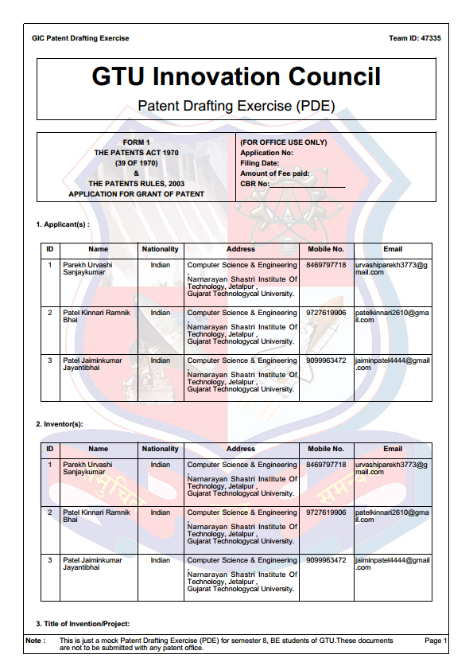

**(2) FORM-2 PDE(Patent Drafting Exercise)**

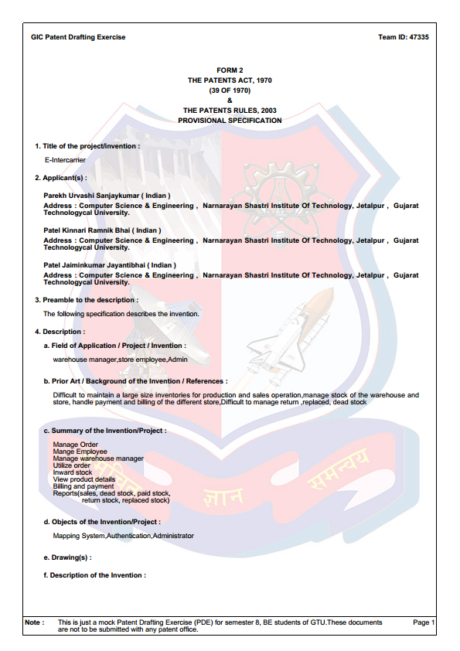

**(3) FORM-3 PDE(Patent Drafting Exercise)**

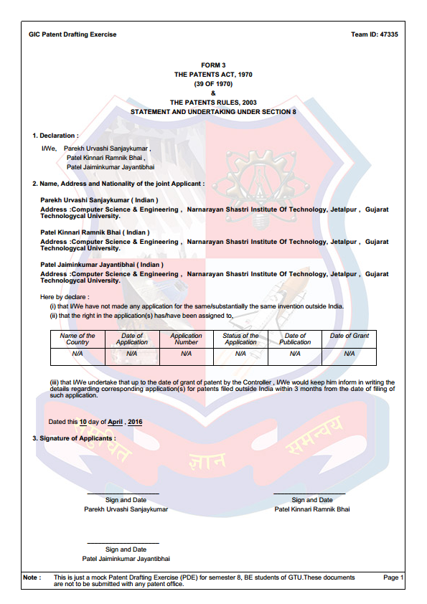

**(B) Completion Certificate**

1. **Submitted By: Parekh Urvashi S.**

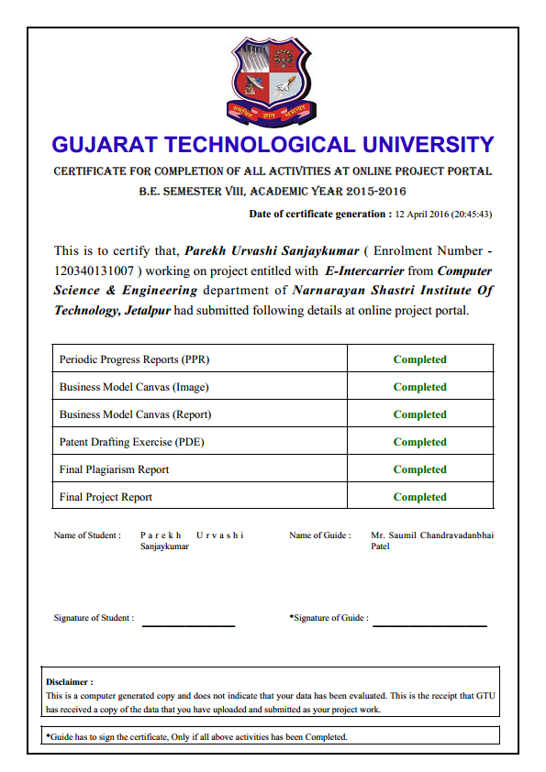

1. **Submitted By: Patel Kinaari R.**

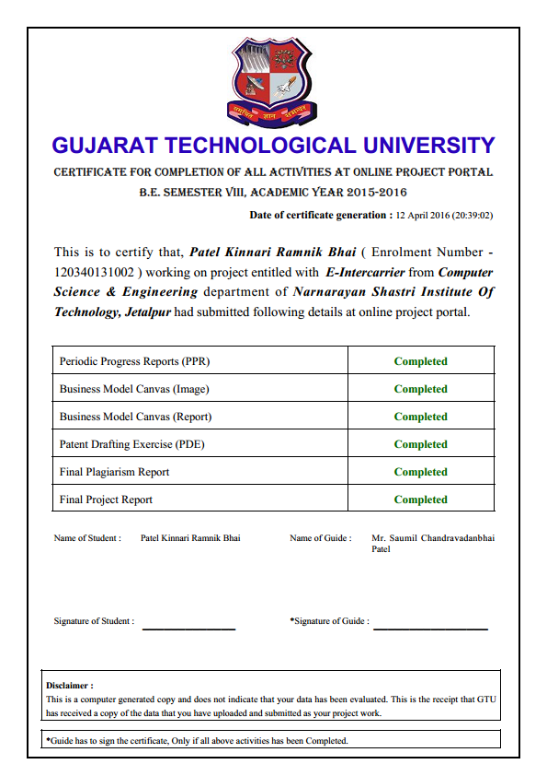

1. **Submitted By: Patel Jaimin J.**

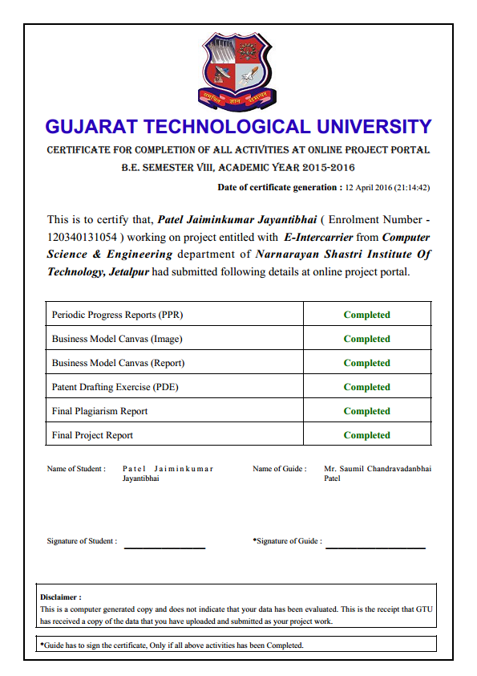

***References***

* www.apachetomcat.org
* www.codecademy.com
* www.coreDevlopersguide.com
* www.eclipse.org
* www.javapoint.com
* www.stackoverflow.com
* www.stackoverflow.com
* www.thinktibits.com
* www.tutorialpoint.com
* www.w3schools.com

**BOOKS:**

* Java: - The Complete Reference
* Advance Java: - Pearson